**API STANDARDS for the OCEAN SHIPPING INDUSTRY**

Oakland, California

July 10-12

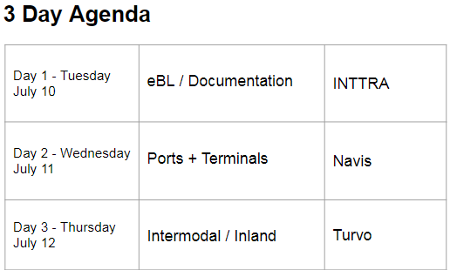

**Day 1 Documentation / eBills of Lading API**

lead by **INTTRA**

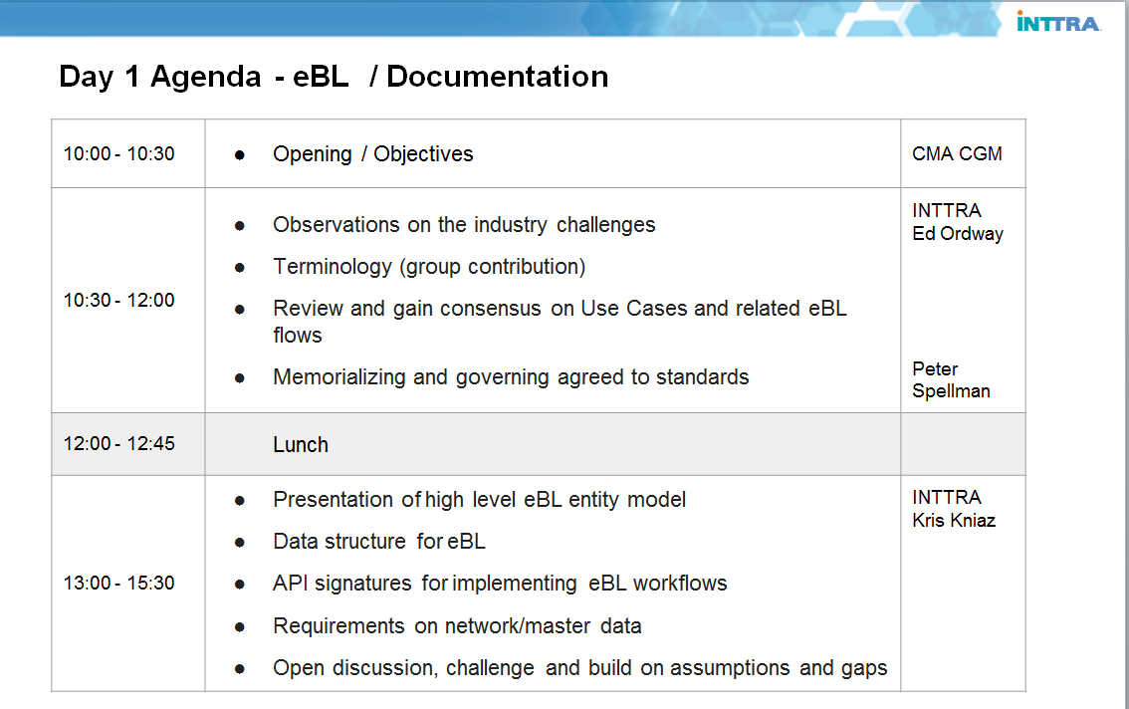

**Opening**

As Eric Caen, CDO of CMA CGM and sponsor of this initiative, was not able to attend; the meeting was opened by Andy Barrons of Navis.

**Documentation / Bills of Lading** (Morning Session)

Ed Ordway (INTTRA) led discussion

Approximately 30 people were in attendance. I do not believe that an attendance sheet was passed for the purpose of noting specific attendees.

The audience was polled to determine:

Technical vs non-technical attendees approximately 50/50

Carrier vs Forwarder vs Other Mix of carriers, forwarders, vendors, port operators

Attending for Day 1, Day 2 or Day 3 Day 1 had very few

Bill of Lading experts None

**Bills of Lading process flows**

A basic review of current standard B/L process flows was given, noting the parties involved and the movement of the B/L between parties. Particular attention was given to the original/negotiable B/L (oBL) as this is the process that involves the greatest number of parties and is complicated with the involvement of banks, and the legal Title implications of this type of B/L.

**eBL Solutions providers**

A number of eBL solutions providers were mentioned, including Bolero, essDocs and eTitle who’s products have all been blessed by the P&I Clubs as equivalent to a paper oBL. Also CargoX was mentioned who is a newer entrant to the market and the one provider whose product is based on Blockchain technology.

**Slides presented to drive process and API oriented conversations**

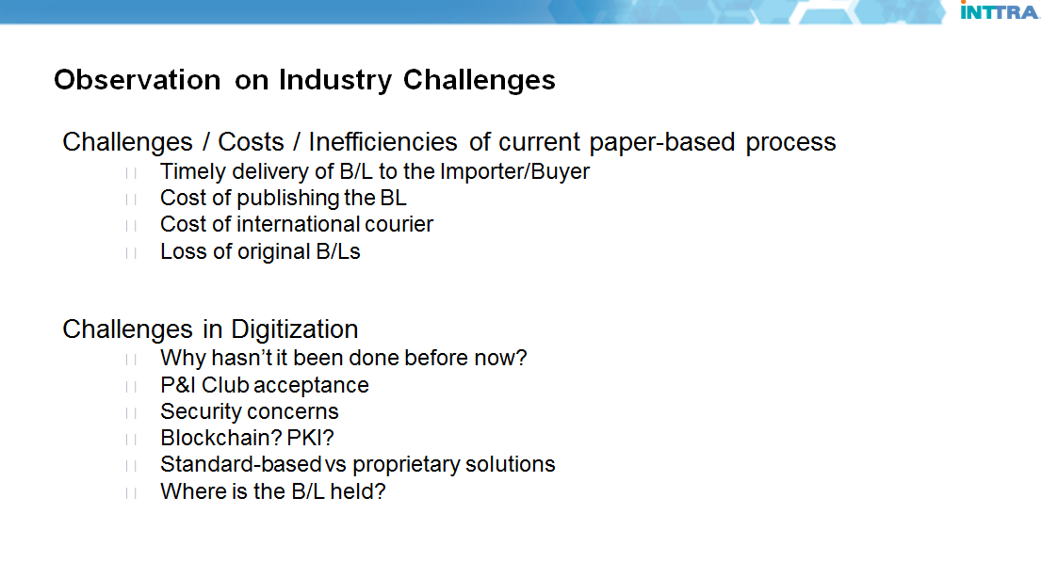

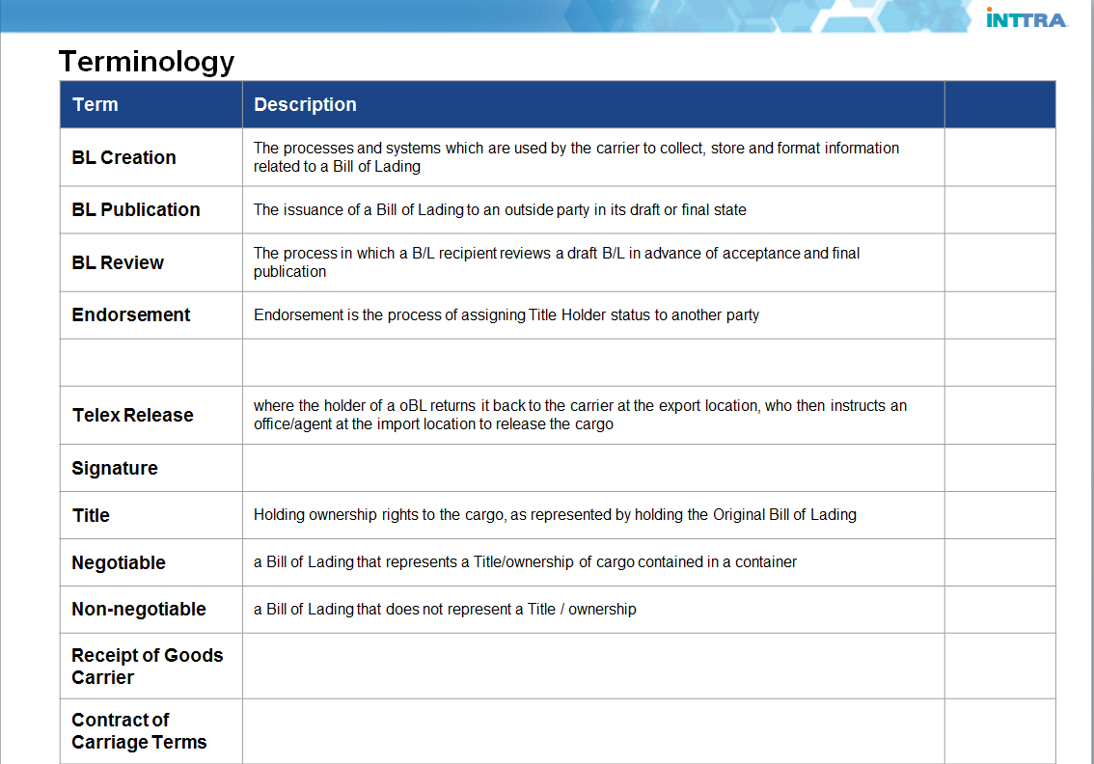

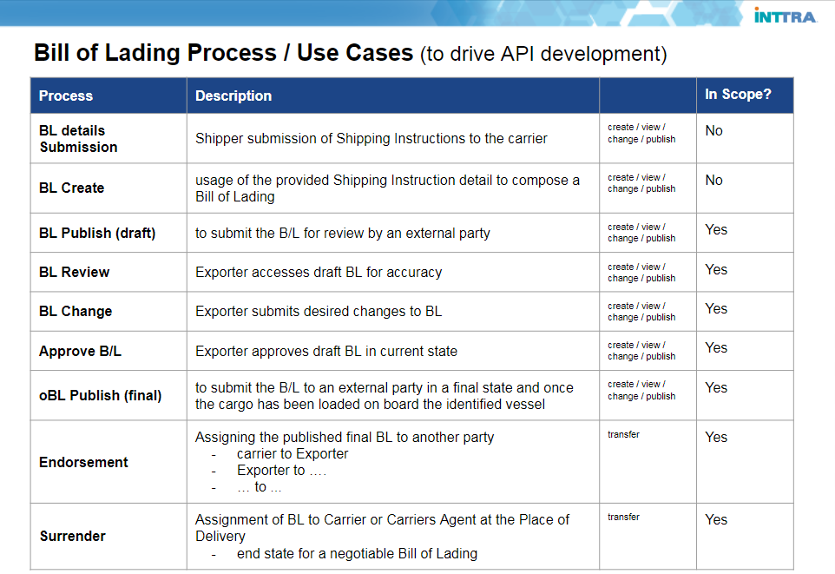

**Notes from the Morning Session**

Group discussed challenges related to the digitization of the BoL process. Questions raised were:

* What is the proper scope?
* Are we looking to digitize creation and distribution ? (Most likely yes)
* What role will blockchain play? (discussion was postponed to the blockchain section)

**B/L update questions raised**

- would this process be similar to EDI where any amendment submission would be a full replace, or will it be possible to provide partial updates just identifying the section to change and the new content.

**RPC vs REST**

There was a brief discussion whether potential solution must adhere to the REST conventions or whether RPC could still be useful.Generally REST is preferred but every usage scenario will be evaluated to establish the proper technical approach.

**The draft review process and versioning**

This was a conversation around the potentially iterative process when as a shipper/forwarder submits a Shipping Instruction resulting in the carrier publishing a Draft B/L for review.

- How should versioning be supported?

- How do we ensure which version is being reviewed and approved?

- What do we do if carrier sends multiple versions and the receiver approves one of the previous ones?

**Contract of Carriage**

The Contract of Carriage is generally “boiler plate” type information that is changed from time to time.

the group felt Contract of Carriage could be a separate structure which would be published, stored in perpetuity (like in a blockchain or similar), and then referred to in the B/L document, as opposed to all text from the Contract of Carriage that was in effect at the time of the BL being included in the B/L in its entirety.

**Digital Representation of Original B/L**

In a digitized environment, the B/L could be effectively managed in one of two manners

1. As a complete B/L payload supported by data elements
2. As a B/L image with supporting data elements

* Some felt that option 2 would be a reasonable first step (MVP), with an ultimate goal of getting to a fully digital data set.

**MVP**

1. What are the 'n' legal requirements for a Bill of Lading
2. What is the API to support #1
3. Prototype, iterate and extend

**Blockchain and INTTRA CONNECT initiative**

Peter Spellman – CTO INTTRA

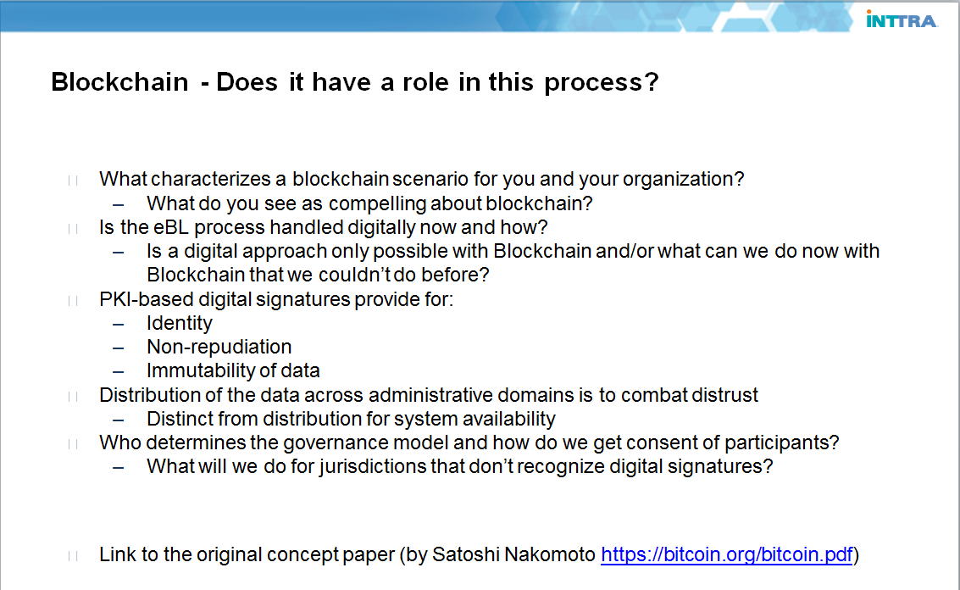

Peter Spellman presented this section on Blockchain, including comparisons to other existing technologies and led a discussion on scalability beyond piloting.

A point was raised regarding Entity identification and management. Where pilot utilization of blockchain has been successful, rolling out the pilot concepts at network scale may be difficult as pilots often skirt difficult problems. N the absence of a central authority managing a common set of entities and their identifiers, each participating company would need to maintain their own set of entity identifiers for all companies that they interact with on the various blockchains.

**Entity Identifier**

lots of discussion.

everyone has their own identifier, or something that trade with 1 or a set of partners

each company doing their own identity management may work in a pilot, but would not be scalable

a global standard would be great (portable entity identifier)

even when DUNS was used, nobody validated that it was a valid DUNS number...it was just an agreed to number

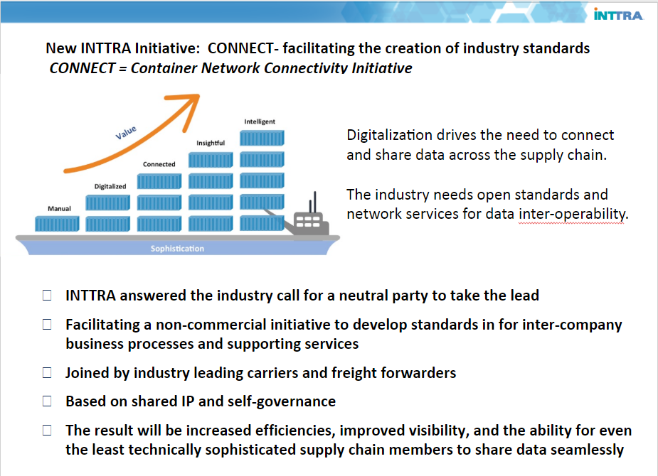

INTTRA introduced an initiative called CONNECT which intends to address both the overall topic of these Oakland meetings, enabling digitalization through standardization for the industry to address technology services and intercompany business processes.

**Notes from the Afternoon Session**

API discussions and prototype demonstration

Kris Kniaz – INTTRA

The presentation on B/L payload and likely APIs to support the oBL process was used to generate additional discussion amongst the participants.

The images below show high level elements of the general BoL xsd schema. The schema and entities are available in the public repository made available by INTTRA <https://github.com/inttra/bol-public>

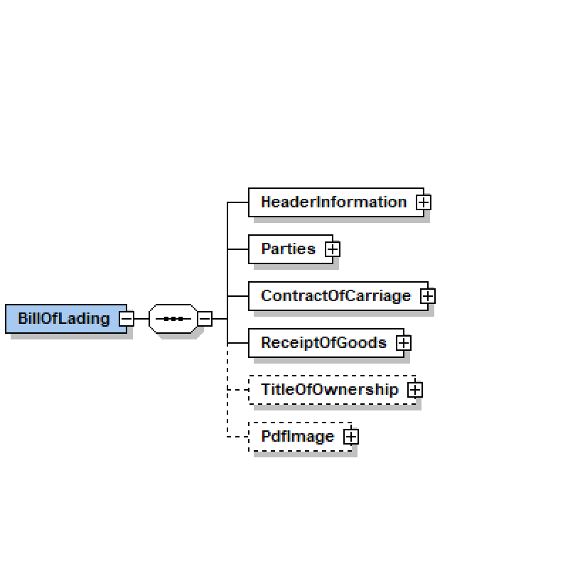

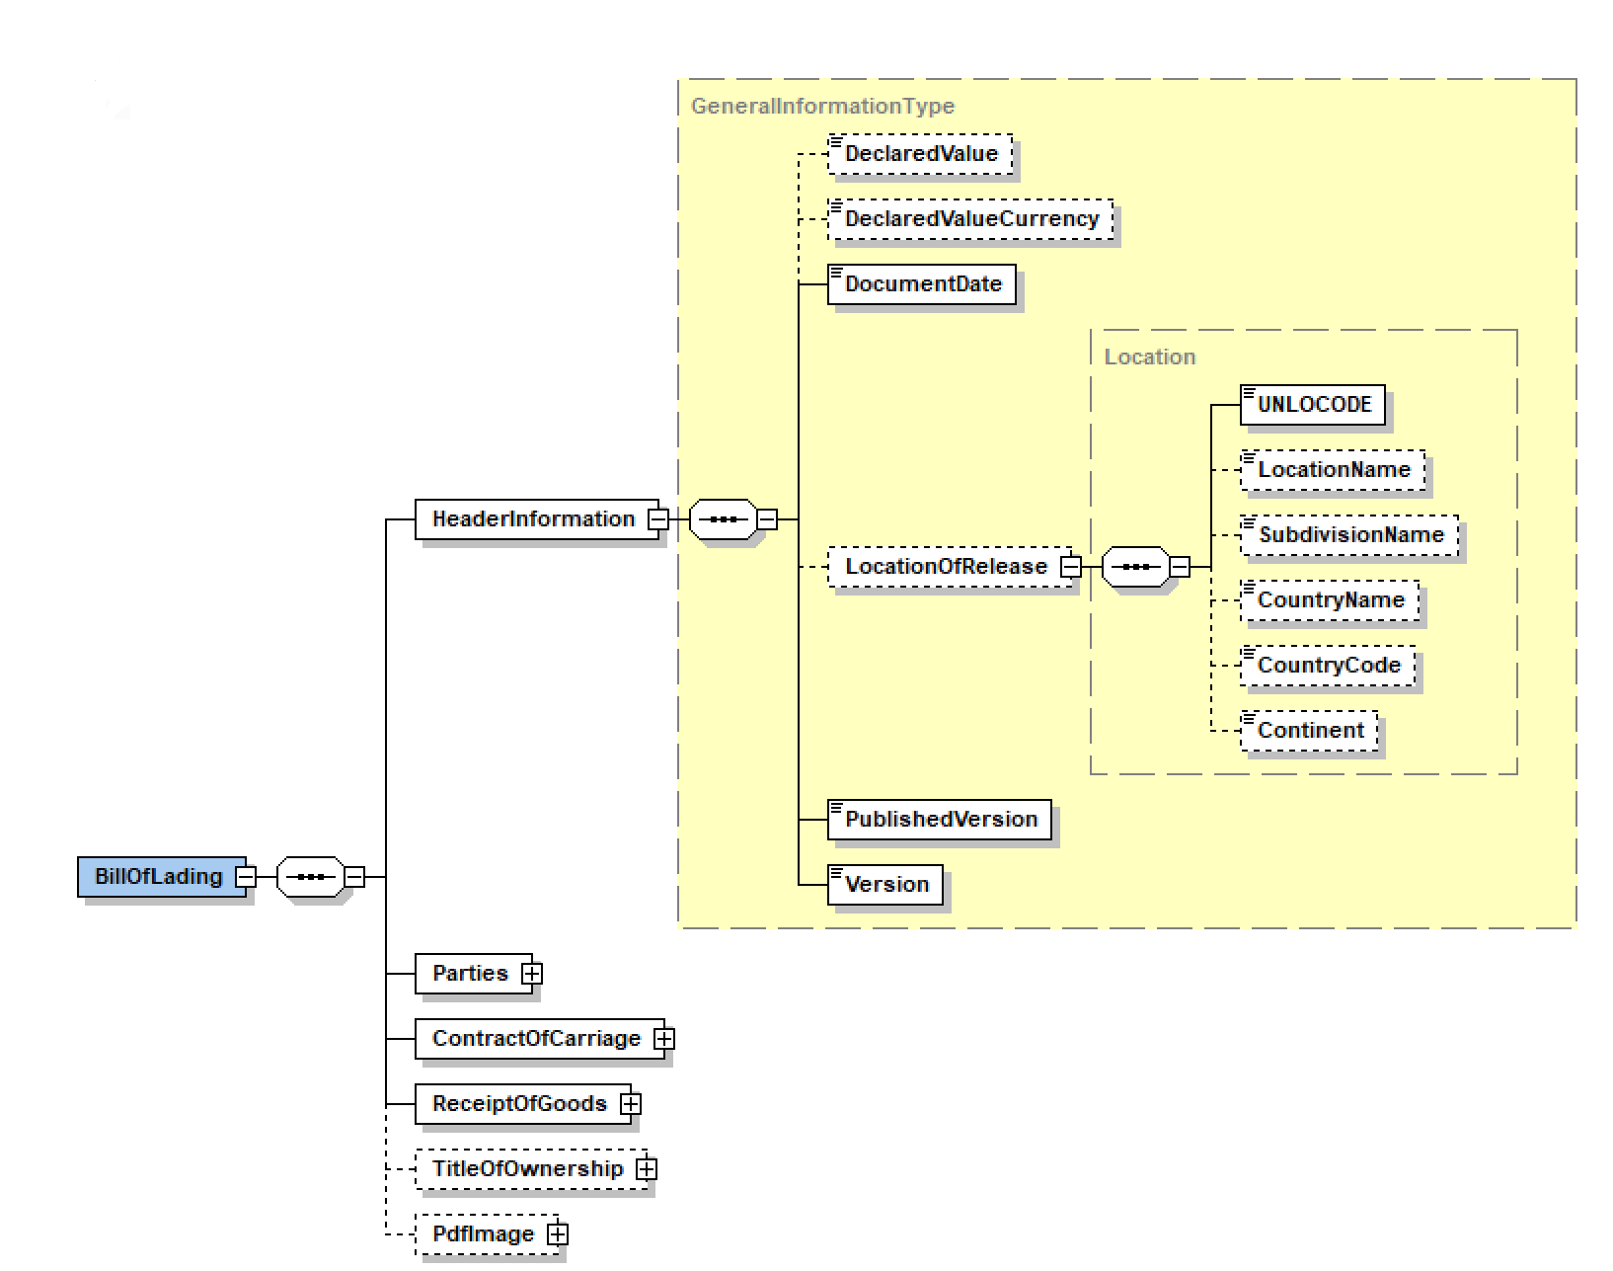

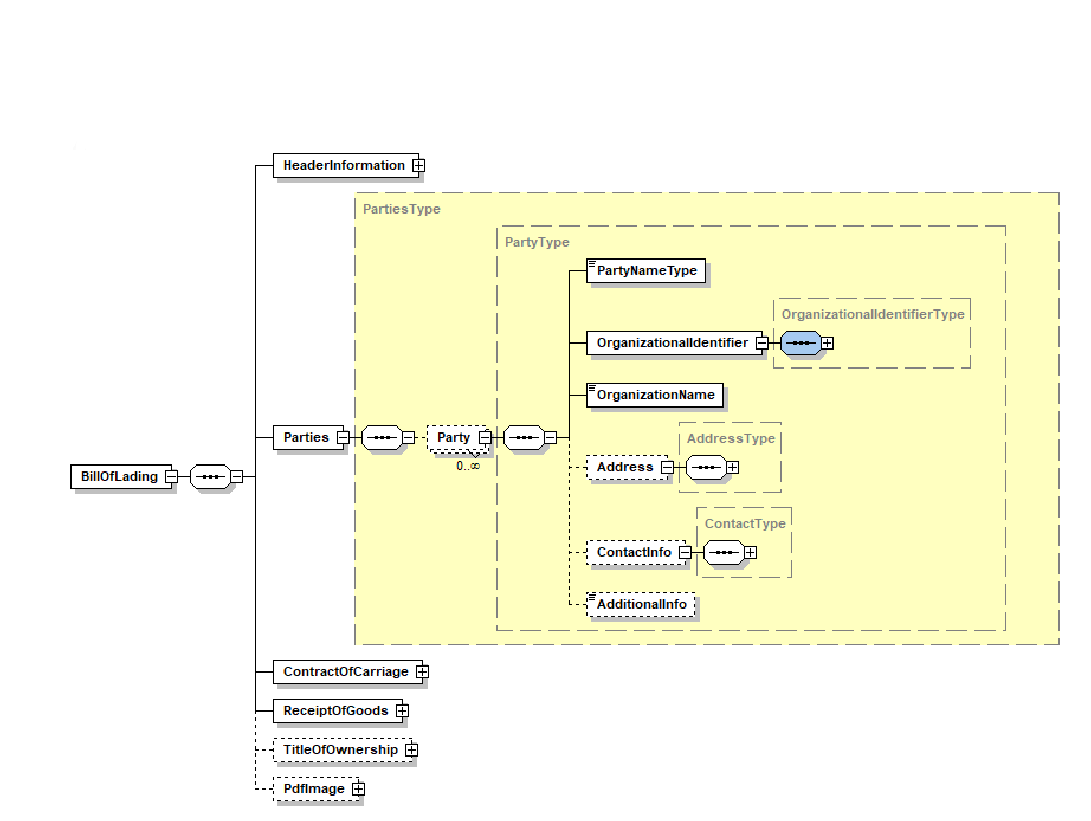

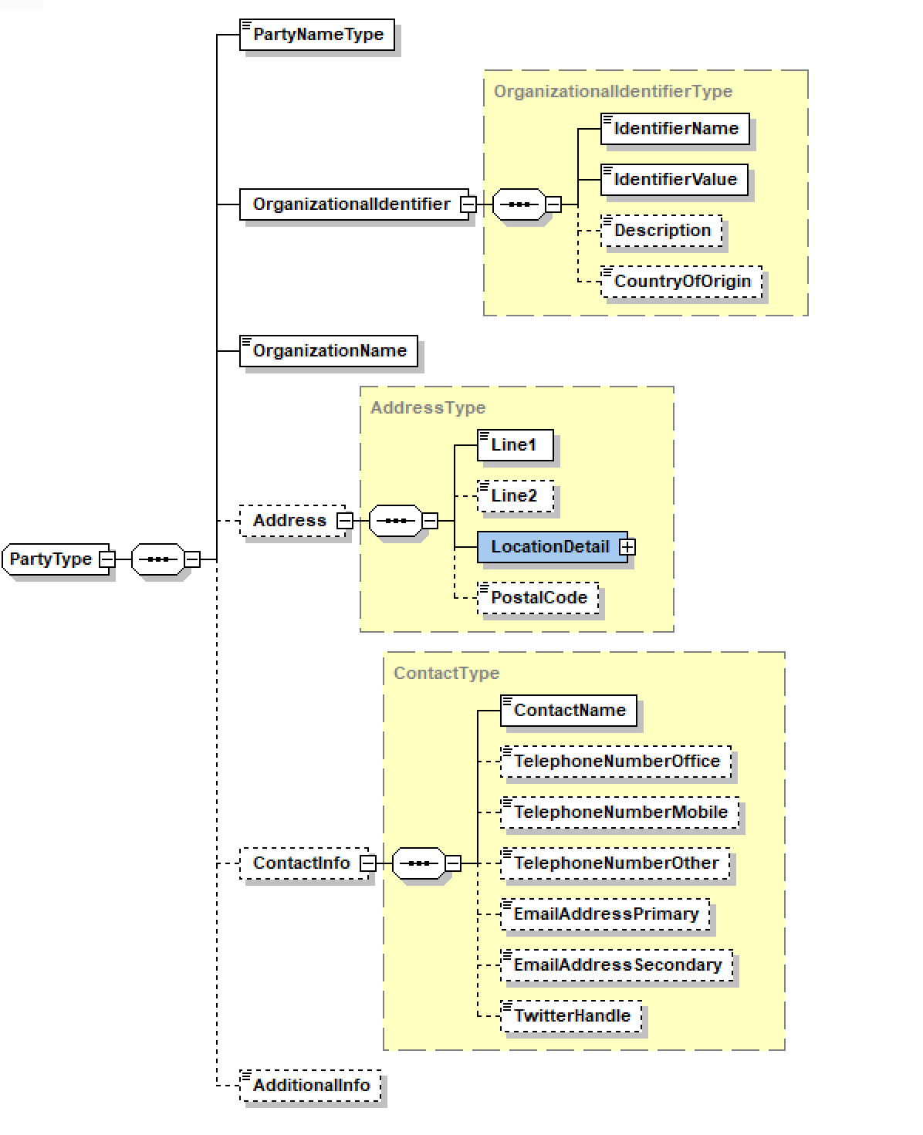

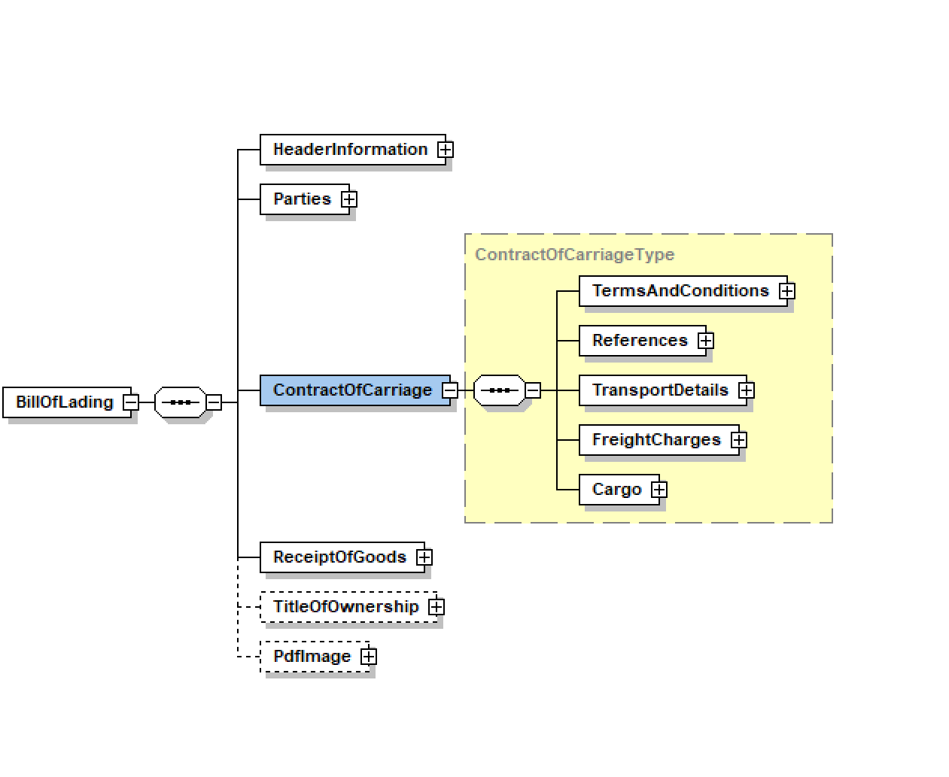

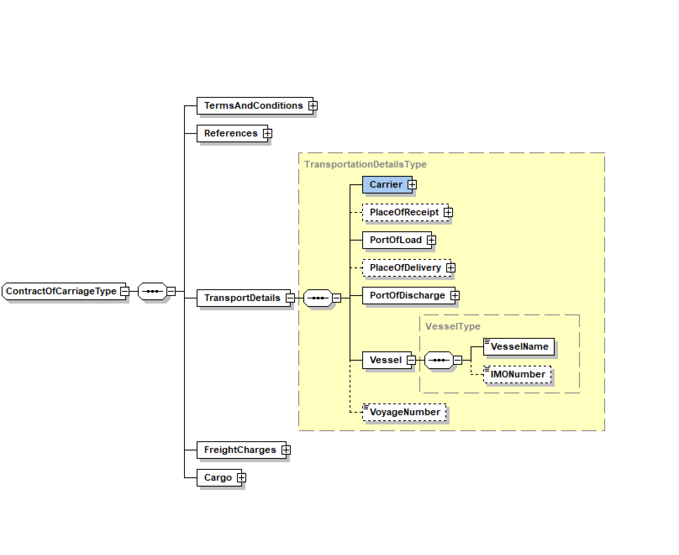

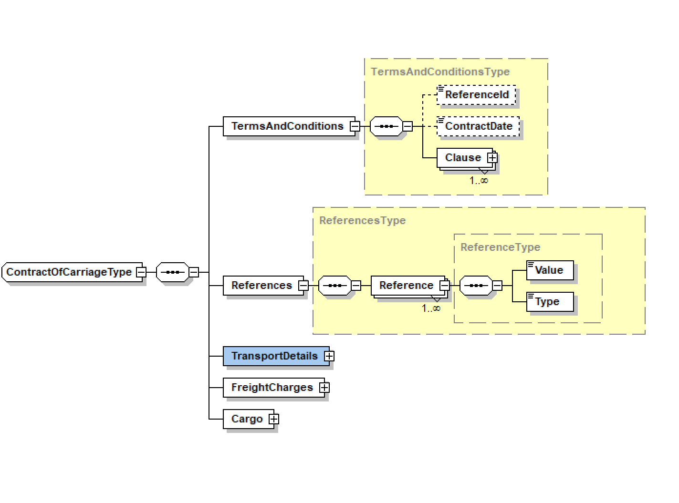

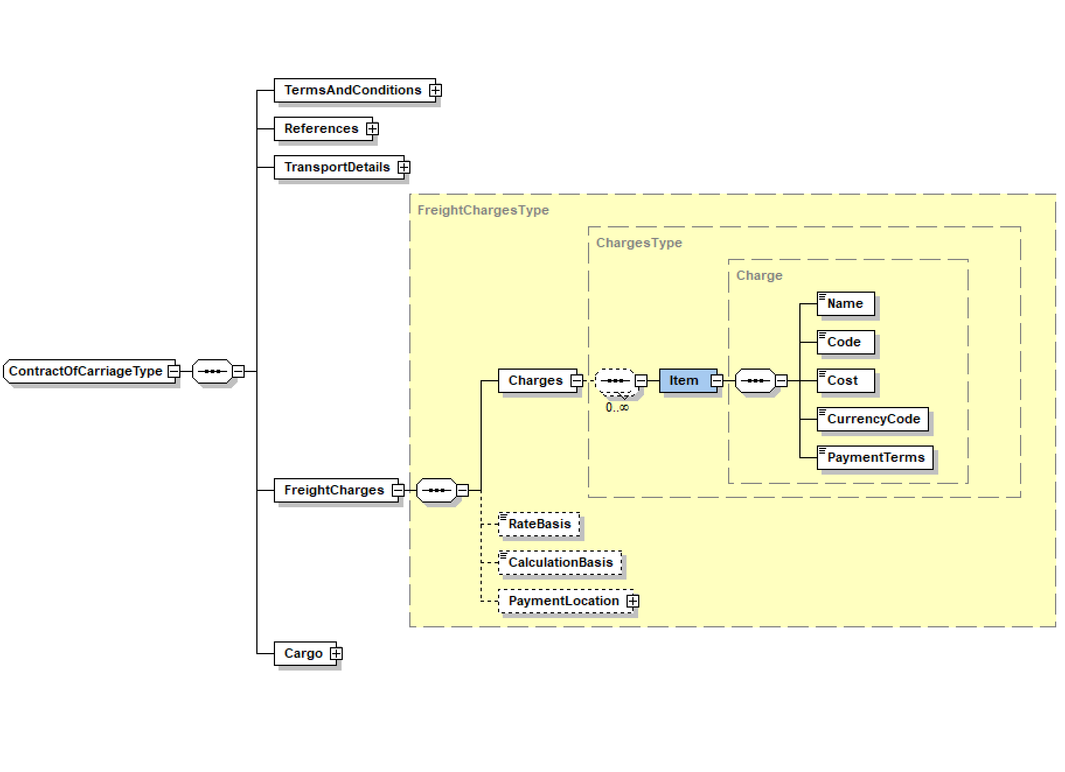

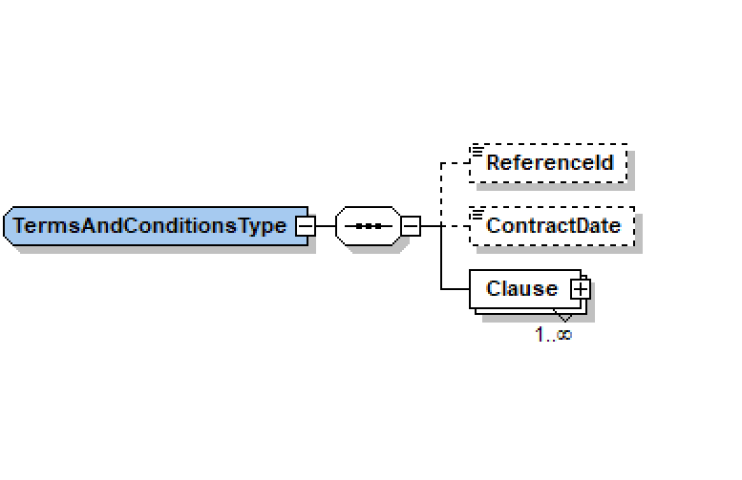

The listing below shows example json message of BoL:

{

"uniqueId": "045fed4b-63c6-4baf-ada3-35d5bd447a9b",

"headerInformation": {

"declaredValue": 20000.34,

"declaredValueCurrency": "USD",

"documentDate": "2018-07-09",

"locationOfRelease": {

"locationId": 0,

"unloCode": "DEBRV",

"countryId": 0,

"locationName": "Bremen",

"countryName": "Deutschland",

"countryCode": "DE"

},

"publishedVersion": 1,

"currentVersion": 1

},

"contractOfCarriage": {

"termsAndConditions": {

"referenceId": "SUDU12345645645",

"contractDate": "2018-07-09",

"clauses": [

{

"content": "Clause 1",

"clauseNumber": 1

},

{

"content": "Clause 2",

"clauseNumber": 1

}

]

},

"references": [

{

"value": "SUDU12345645645",

"type": "BILL_OF_LADING_NUMBER"

},

{

"value": "8SZC6789",

"type": "BOOKING_NUMBER"

},

{

"value": "72934343434343434",

"type": "EXPORTER_REFERENCE_NUMBER"

}

],

"transportDetails": {

"carrier": {

"partyType": "CARRIER",

"organizationalIdentifier": {

"identifierName": "SCAC",

"identifierValue": "SUDU"

},

"organizationName": "HAMBURG SUD"

},

"portOfLoad": {

"locationId": 0,

"unloCode": "BRSSL",

"countryId": 0,

"locationName": "SALVADOR",

"subdivisionName": "BA",

"countryName": "BRASIL"

},

"placeOfDelivery": {

"locationId": 0,

"unloCode": "JPYKK",

"countryId": 0,

"locationName": "YOKKAICHI",

"countryName": "JAPAN"

},

"portOfDischarge": {

"locationId": 0,

"unloCode": "KRPUS",

"countryId": 0,

"locationName": "BUSAN",

"countryName": "South Korea"

},

"vessel": {

"vesselName": "PEDRO ALVAREZ CABRAL"

},

"voyageNumber": "049 S"

},

"freightCharges": {

"charges": [

{

"name": "Ocean Freight",

"code": "BAS",

"cost": 1700,

"currencyCode": "USD",

"included": false,

"applicable": false

},

{

"name": "Bunker Adjustment",

"code": "BAF",

"cost": 328,

"currencyCode": "USD",

"included": false,

"applicable": false

},

{

"name": "Chasis Charge",

"code": "CUC",

"cost": 70,

"currencyCode": "USD",

"included": false,

"applicable": false

},

{

"name": "Port Security Fee",

"code": "PSS",

"cost": 70,

"currencyCode": "USD",

"included": false,

"applicable": false

}

],

"rateBasis": "DOCUMENT",

"paymentLocation": {

"locationId": 0,

"unloCode": "BRSSL",

"countryId": 0,

"locationName": "SALVADOR",

"subdivisionName": "BA",

"countryName": "BRASIL"

}

},

"cargo": [

{

"lineNumber": 1,

"equipment": {

"container": {

"identifier": "TRLU3936006",

"code": "22G0",

"weightsAndVolumes": {

"tareWeight": {

"unit": "KGS",

"value": 2220

}

}

},

"seal": {

"identifier": "5753002"

},

"mark": [

"Cnt. Ld. FCLFCL",

"VERO CERAMIC CO LTD",

"PO 156-Y-11-074-201807"

]

},

"goods": {

"packageDetails": [

{

"quantity": 20,

"packageMeasurements": {

"netWeight": {

"unit": "KGS",

"value": 25000

},

"grossWeight": {

"unit": "KGS",

"value": 25800

}

},

"hsCommodityCode": "25199090",

"marks": [

"20 BIG BAGS",

"NATURAL MAGNESIUM CARBONATE (MAGNESITE)",

"INOICE 000169/18"

]

}

],

"totalNumberOfPackages": 160,

"totalWeight": {

"unit": "KGS",

"value": 200800

},

"totalVolume": {

"unit": "CBM",

"value": 265.6

}

}

}

]

},

"titleOfOwnership": {

"titleHolder": {

"partyType": "NOTIFY_PARTY",

"organizationName": "BANK OF IMPORT",

"address": {

"line1": "KISHI-HARRAKO 12 BLDG 10",

"locationDetail": {

"locationId": 0,

"countryId": 0,

"locationName": "TOKYO",

"countryName": "JAPAN"

},

"postalCode": "750-1005"

}

}

},

"parties": {

"parties": [

{

"partyType": "SHIPPER",

"organizationName": "KUEHNE + NAGEL SERV LOGIST LTDA",

"address": {

"line1": "R FERNANDEZ TOURINHO, 470 SL 706/707 ",

"locationDetail": {

"locationId": 0,

"countryId": 0,

"locationName": "BELO Horizonte",

"subdivisionName": "MG",

"countryName": "BRASIL"

},

"postalCode": "30112-000"

},

"additionalInfo": "AGENT OF BLUE ANCHOR LINE"

},

{

"partyType": "CONSIGNEE",

"organizationName": "KUEHNE + NAGEL LTD",

"address": {

"line1": "NISHI-HONMACHI INTES BUILDING 10/F",

"line2": "2-3-10 NISHI-HONMACHI",

"locationDetail": {

"locationId": 0,

"countryId": 0,

"locationName": "NISHI-KU OSAKA",

"countryName": "JAPAN"

},

"postalCode": "550-0005"

},

"additionalInfo": "AGENT OF BLUE ANCHOR LINE"

},

{

"partyType": "NOTIFY_PARTY",

"organizationName": "KUEHNE + NAGEL LTD",

"address": {

"line1": "NISHI-HONMACHI INTES BUILDING 10/F",

"line2": "2-3-10 NISHI-HONMACHI",

"locationDetail": {

"locationId": 0,

"countryId": 0,

"locationName": "NISHI-KU OSAKA",

"countryName": "JAPAN"

},

"postalCode": "550-0005"

},

"additionalInfo": "AGENT OF BLUE ANCHOR LINE"

},

{

"partyType": "NOTIFY_PARTY",

"organizationName": "BANK OF IMPORT",

"address": {

"line1": "KISHI-HARRAKO 12 BLDG 10",

"locationDetail": {

"locationId": 0,

"countryId": 0,

"locationName": "TOKYO",

"countryName": "JAPAN"

},

"postalCode": "750-1005"

}

},

{

"partyType": "CARRIER",

"organizationalIdentifier": {

"identifierName": "SCAC",

"identifierValue": "SUDU"

},

"organizationName": "HAMBURG SUD"

}

]

}

}

**Parties**

How do we align on identifiers?  Each company has their own idea.  Would we allow a set of types (e.g. SCAC, DUNS) and an identifier in each namespace.

Does a party need to be known to the network and resolvable?

* some feel not, or that it really is not an issue for that standard itself
* if the business intent and logic suggests that each party named in a B/L may need to be able to access the record/transaction, then each party would need to be explicitly identified and resolvable. If some parties are informational and do not need access, then resolution is not necessary.

**Versioning**

Need to work through versioning requirements.

Does endorsement and/or assignment change the version?

Version Number could be a new Hash for each iteration. But a Hash does not convey well in outside of the system environment (for example if the Shipper needs to discuss the version of the draft with the Carrier).

Even in advance of the Final BL issuance, BL revisions are very important since each is considered an amendment and will be charged as such. Most carriers do not allow revisions/amendments via EDI

**Locations**

Location codes (like UN/Locodes) versus textual representations?  What would be canonical location codes?

**Terms and Conditions (T&C)**

As mentioned, there was a suggestion that there could/should be a specific API to view the relevant T&C stored separate from the B/LO document. It doesn’t need to be stored for each and every B/L that the T&C version would be relevant. Blockchain, or similar, would help ensure that the T&C version does not change.

**Other documents**

Some countries do, or may, require certain documents to accompany a bill of lading and in paper format.

**Transshipment**

Is this relevant? Does final vessel at Final Destination really matter? Would this require the B/L to be updated at some point after issuance of Final B/L?

*\*\*INTTRA Comment: topics such as this are certainly to be well known by experts in B/L handling. Due to the lack of any B/L experts attending this meeting we did at times discuss/debate topic which will be quickly and easily answered with an extended attendance.*

**Reefer**

what information is required for Reefer in a bill of lading (again, dont need to debate)

*(see ** comment above)*

**Next Steps**

INTTRA demonstrated B/L schema and API

* INTTRA to share schema and API in some public place
* Post to developer portal

BL Payload

* Determine resources to compare the currently available specifications (current provider specs, etc) and see how well they align or differ
* Consider picking one. Why re-invent the wheel. Need to determine legal implications, copyright
* why re-invent the wheel

Open Requests

* convergence of things that exist. Would INTTRA consider doing the work to compare/contrast formats? (see B/L Payload above)
* Would INTTRA consider establishing a development environment / sandbox for any pilot activity?

Future Meetings

* INTTRA agreed to take the lead here
* Should we bring together the competing BL solutions providers? (likely yes)

Definition of scope

* Does this process support the BL review process, or just the process once the final is issued?
* Does this process support just the oBL process where a Title Registry is needed, or does it also offer value for Sea Waybills?
* Would this process support the collection and distribution of the full Document Set required for customs clearance, or will it just focus on B/L?
* Can we consider an MVP which would support the publication of a oBL in PDF (or other image format) along with key minimum mandatory data, or must this be a complete B/L transaction payload?